AGE-GROUP-WISE ANALYSIS OF RAPE CASES IN INDIA USING DATA SCIENCE TECHNIQUES

A PROJECT REPORT
Submitted by
Sudhanshu Maurya (12406865)
in partial fulfillment for the award of the degree
of
BACHELOR OF TECHNOLOGY
IN
COMPUTER SCIENCE AND ENGINEERING

Lovely Professional University, Punjab
APRIL 2025

ACKNOWLEDGEMENT

I would like to sincerely thank Maneet Kaur, Aashima and all my respectful mentors for their valuable guidance and support throughout this project. I am also grateful to the faculty of the School of Computer Science and Engineering at Lovely Professional University for their encouragement and expert advice. Special appreciation goes to my friends and family for their constant motivation and understanding during this journey. Their collective support made this project possible.

Sudhanshu Maurya
12406865

TABLE OF CONTENTS
- Introduction
- Objectives
- Dataset Description
- Data Preprocessing
- Summary Statistics
- Distribution Analysis
- Rural vs Urban Comparison
- Relationship Analysis
- Outlier Detection
- Normality Testing
- Correlation Analysis
- Hypothesis Testing
- State-wise Analysis
- Advanced Visualizations
- Double Burden Analysis
- Dashboard Summary
- Key Insights
- Conclusion

Github Link :

Linkedin Link :

INDIA DISTRICT HEALTH & NUTRITION ANALYSIS (NFHS 2015)

1. Introduction
This project analyzes district-level health, nutrition, and socioeconomic indicators across India using NFHS 2015 data set. The goal is to identify patterns, relationships, and disparities between rural and urban populations and derive meaningful insights for policy and improvement.

2. Objectives
• Understand structure and quality of data set
• Perform data cleaning and prepossessing
• Analyze key health indicators
• Compare rural vs urban outcomes
• Detect patterns, correlations, and outliers
• Derive actionable insights

Dataset Description
The dataset contains district-level information across India including:
- Literacy rates (male & female)
- Maternal & child health indicators
- Nutrition (stunting, wasting, underweight)
- Healthcare access (institutional births, immunization)
- Infrastructure (sanitation, electricity, fuel)
Each row represents a district with multiple health-related attributes.

Data Preprocessing
Steps performed:
- Renamed columns for clarity
- Removed duplicates
- Dropped irrelevant columns (Country, Year)
- Converted categorical data (Residence Type)
- Handled missing values using median imputation
- Created subsets:
  - Total
  - Rural
  - Urban
Result: Clean, structured dataset ready for analysis

Summary Statistics
Basic statistical measures (mean, median, std, range) computed for key variables.
Indicator | Mean | Median | Std Dev | Min | Max | Range
Women Literacy | 68.24 | 69.00 | 14.51 | 27.10 | 99.60 | 72.50
Men Literacy | 84.99 | 86.30 | 8.50 | 46.80 | 100.0 | 53.20
Institutional Births | 78.82 | 83.10 | 17.29 | 9.70 | 100.0 | 90.30
Full Immunization | 62.21 | 62.60 | 17.28 | 7.10 | 100.0 | 92.90
Stunting | 35.99 | 36.20 | 9.92 | 12.40 | 65.10 | 52.70
Wasting | 20.60 | 20.10 | 7.66 | 1.80 | 46.90 | 45.10
Underweight Under5 | 32.71 | 32.90 | 11.70 | 5.80 | 66.90 | 61.10
Women Anaemia | 51.45 | 52.70 | 12.18 | 13.10 | 84.10 | 71.00
Child Anaemia | 56.40 | 58.30 | 15.28 | 7.80 | 95.80 | 88.00
Child Marriage Women | 24.61 | 22.60 | 13.55 | 0.00 | 67.90 | 67.90
Caesarean Rate | 16.55 | 12.10 | 13.02 | 0.30 | 79.90 | 79.60
Clean Cooking Fuel | 37.61 | 32.40 | 23.16 | 3.70 | 99.50 | 95.80
Improved Sanitation | 48.03 | 46.20 | 22.61 | 6.90 | 99.50 | 32.60
Women Overweight | 18.80 | 16.90 | 8.98 | 2.40 | 48.70 | 46.30
Men High Blood Sugar | 7.78 | 7.20 | 3.52 | 0.60 | 22.10 | 21.50

Insight:
- Literacy and institutional births are relatively high
- Malnutrition indicators still significantly present
- Large variation across districts

Distribution Analysis

Insight:
- Most variables are skewed (not normal)
- Health indicators vary widely across districts
- Some indicators show clustering (e.g., literacy)

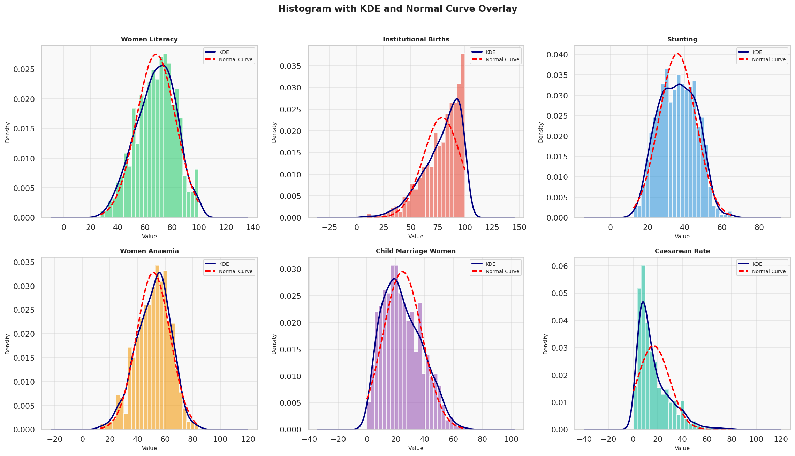

Rural vs Urban Comparison

Insight:
- Urban areas perform better in:

  - Literacy
  - Institutional births
  - Immunization

- Rural areas show:

  - Higher child marriage
  - Higher malnutrition
  - Lower sanitation access

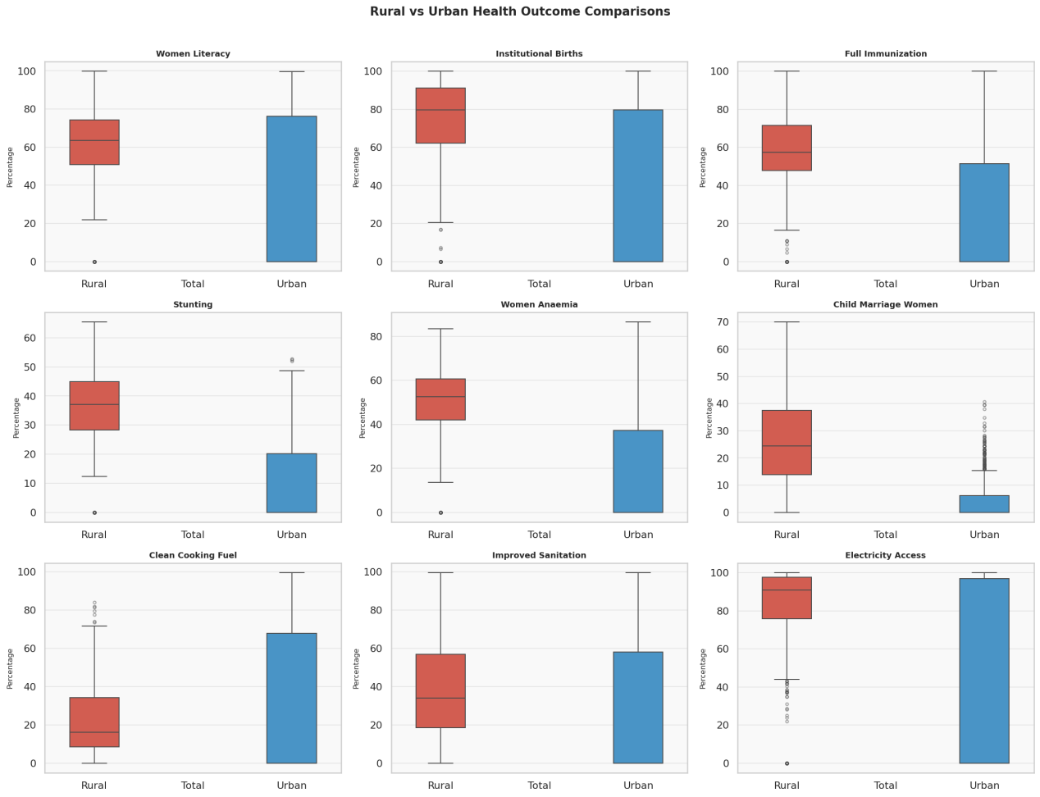

Relationship Analysis (Scatter Plots)
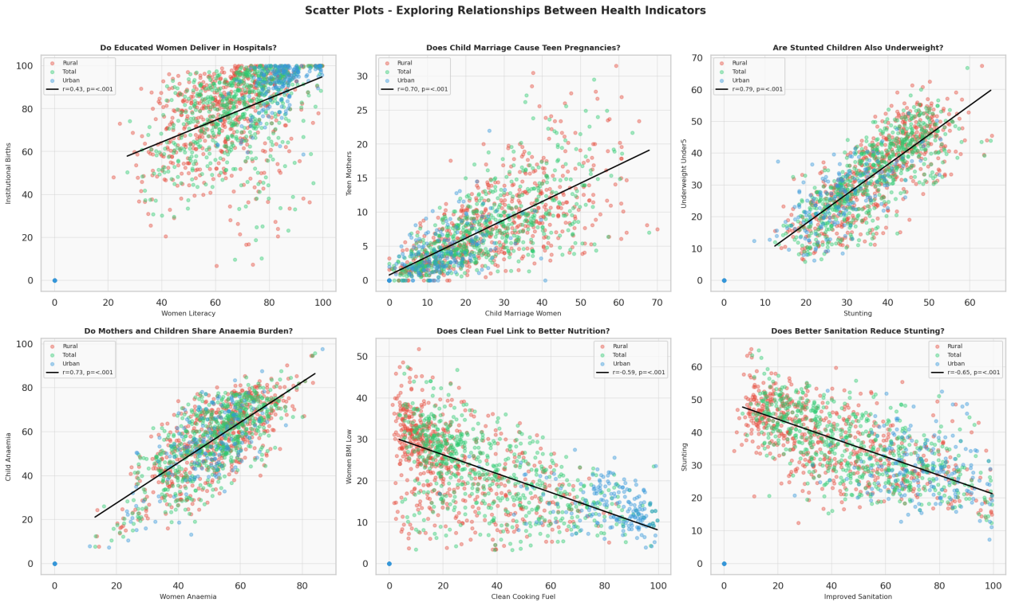

Key Findings:
- Literacy ↑ → Institutional births ↑
- Child marriage ↑ → Teen pregnancy ↑
- Stunting ↑ → Underweight ↑
- Sanitation ↑ → Stunting ↓
Strong correlations indicate cause-effect patterns

9. Pairplot & Multivariate Analysis
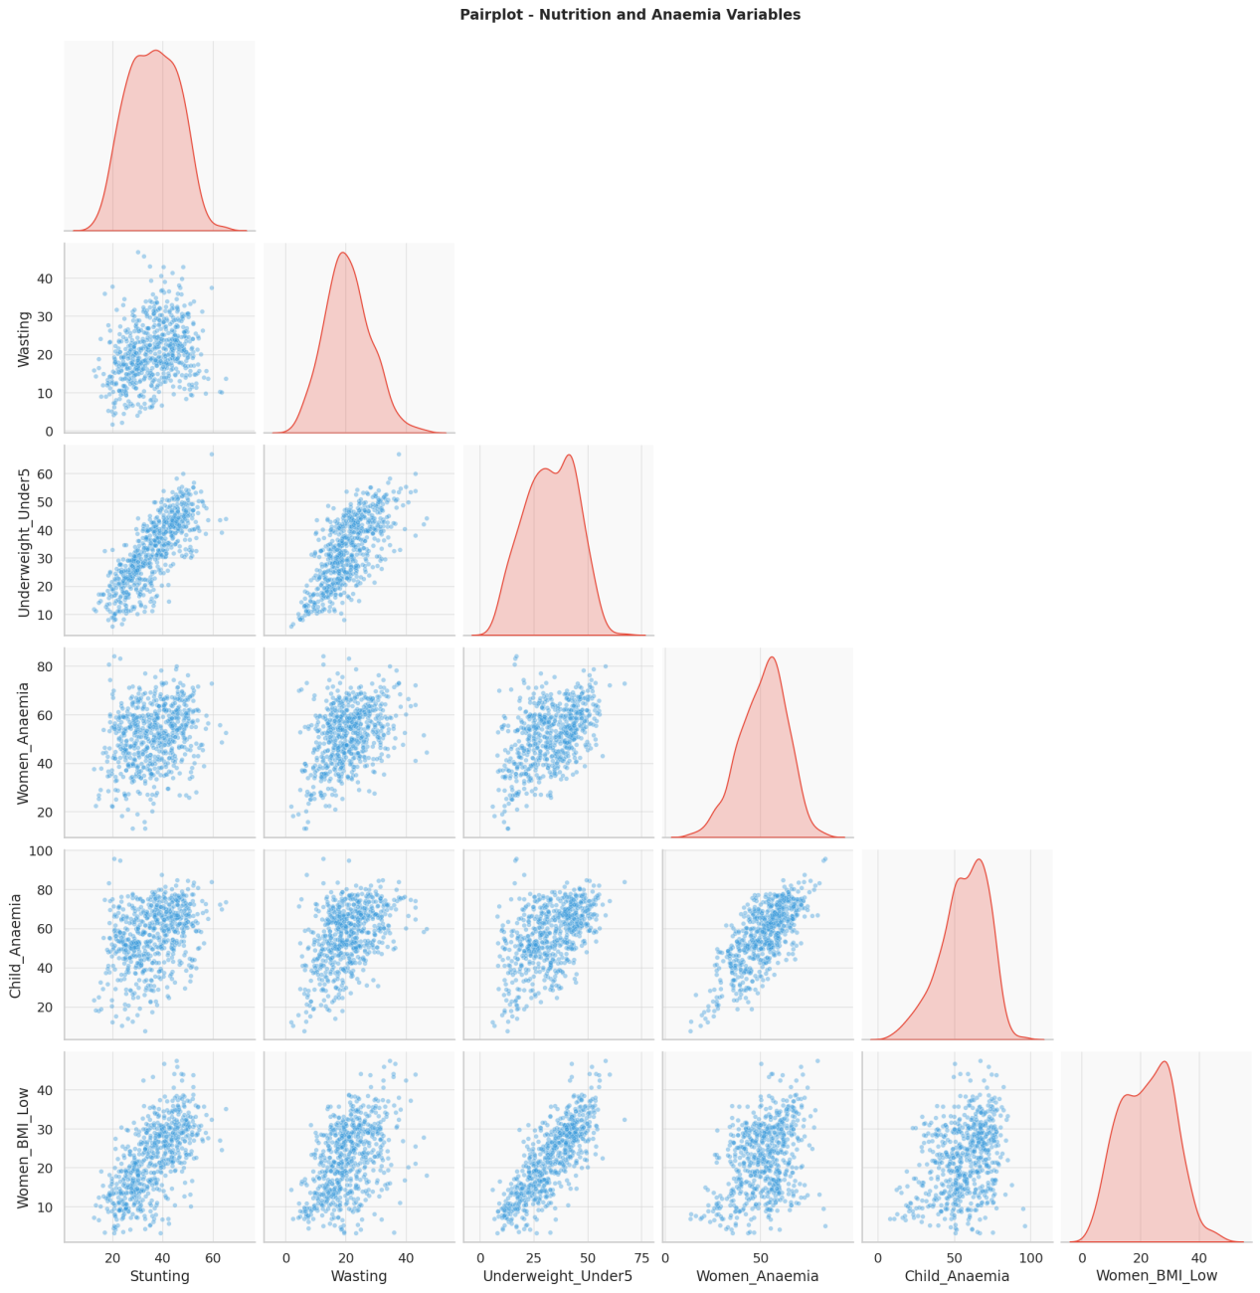

Insight:
- Malnutrition indicators are strongly interrelated
- Anaemia in women and children highly correlated
- Clear clustering of health conditions

Outlier Detection

Insight:
- High outliers in:
  - Caesarean rate
  - Delivery cost
- Indicates inequality in healthcare access
- Some districts perform extremely differently
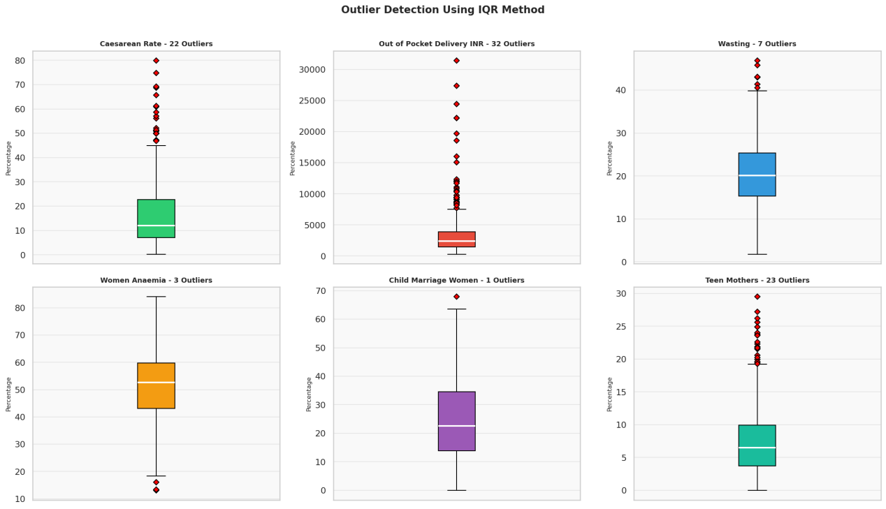

Normality Testing

Insight:
- Most variables are NOT normally distributed
- Confirms need for robust statistical methods
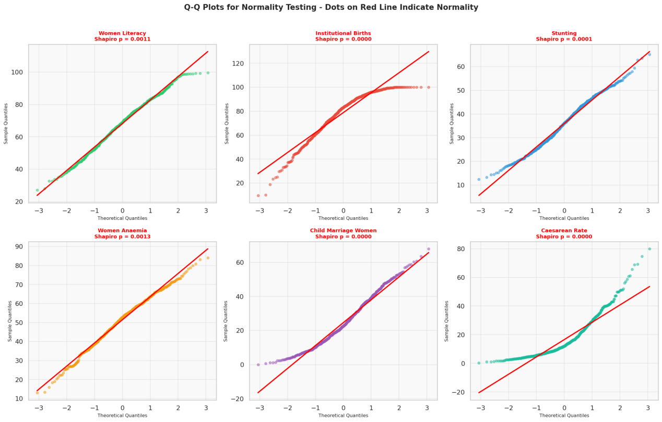

Correlation Analysis
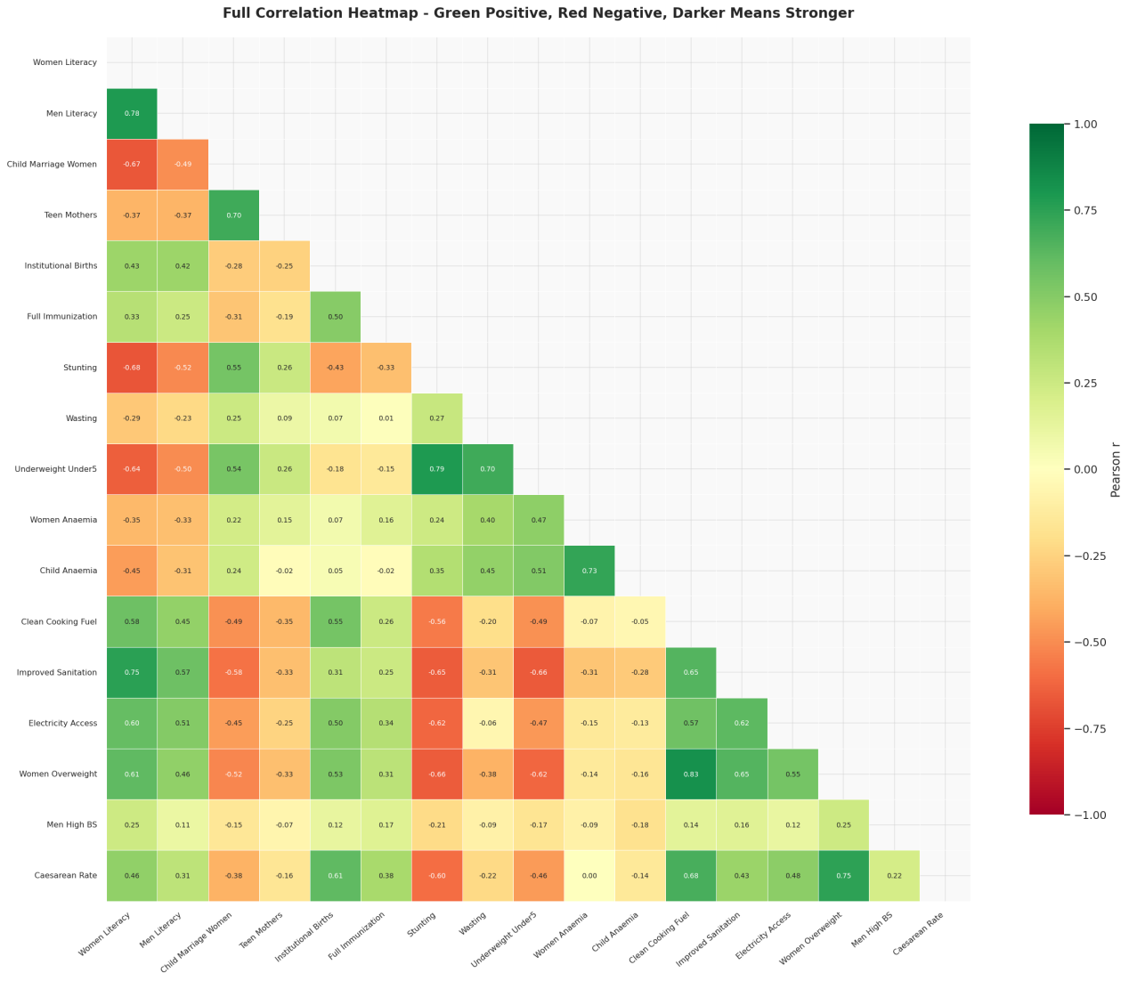

Key Observations:
- Literacy negatively correlated with stunting
- Sanitation strongly improves health outcomes
- Clean fuel linked with better nutrition

13. Statistical Significance

Insight:
- Many rural vs urban differences are statistically significant
- Confirms inequality is real, not random
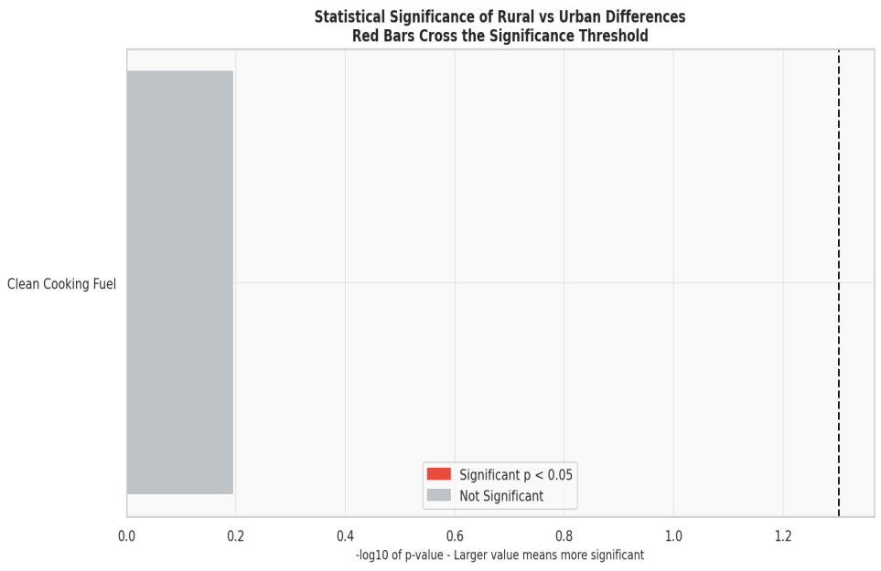

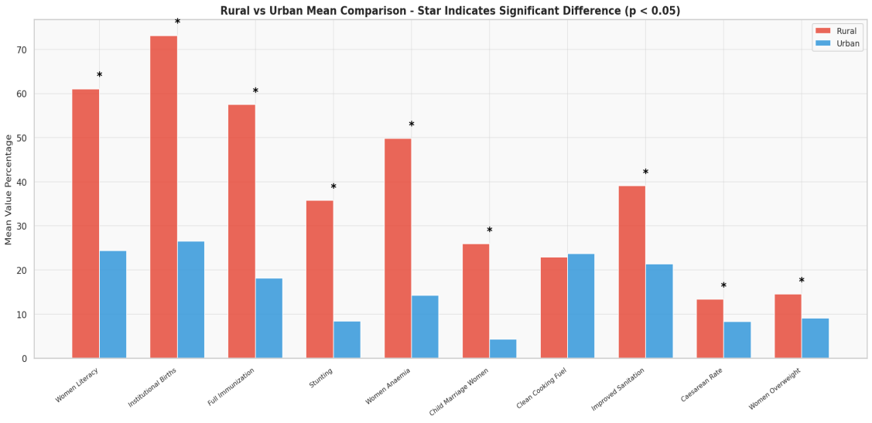

State-wise Analysis
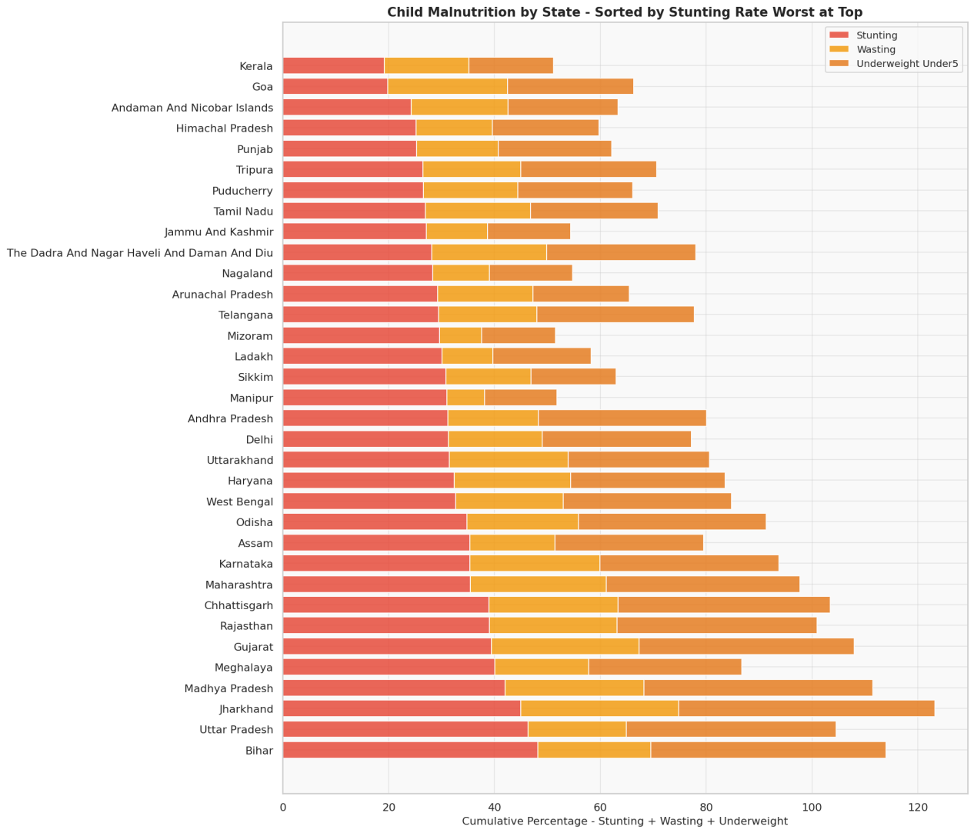
• Worst performing states:
- Bihar
- Uttar Pradesh
- Jharkhand
• Best performing:
- Kerala
- Goa

15. Advanced Visualizations
Insight:
- High stunting + high anaemia states identified easily
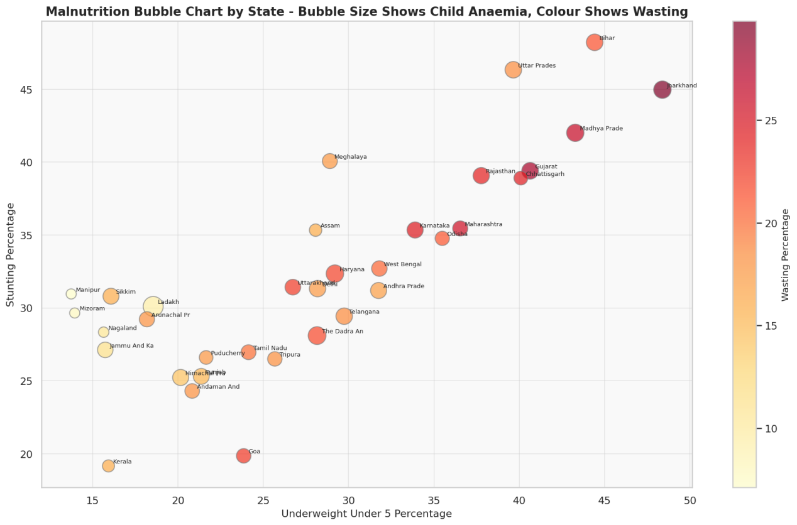
Insight:
- Literacy quartiles clearly affect health outcomes
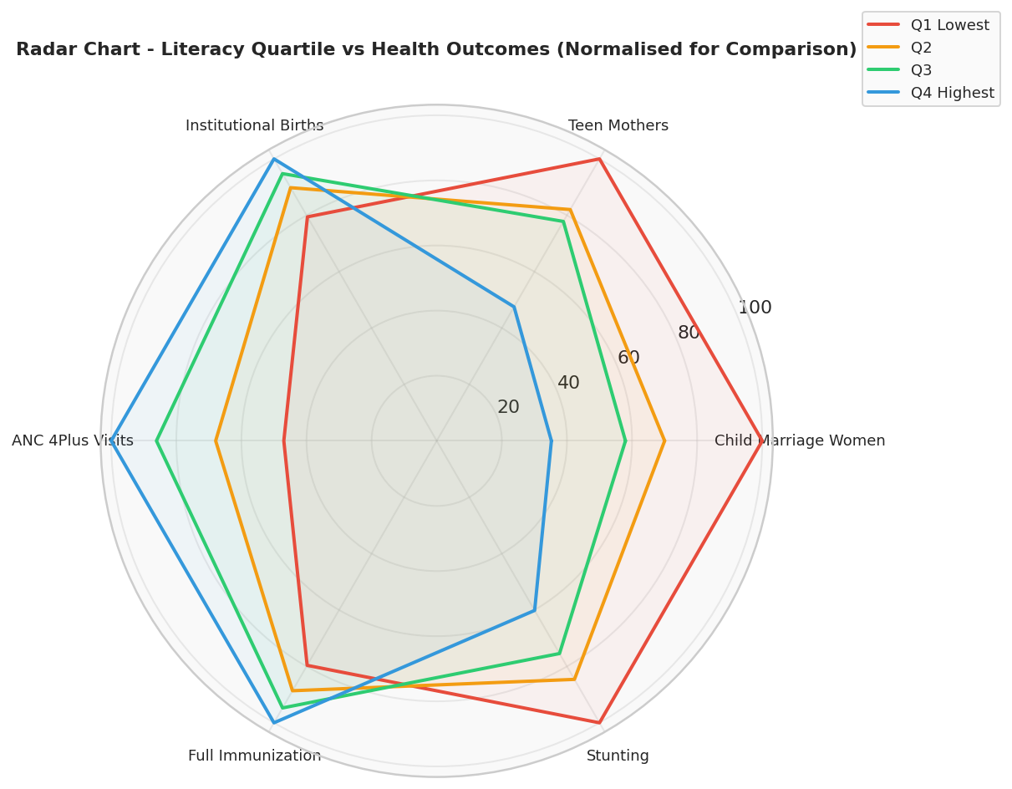

16. Key Insights
• Female literacy is strongest driver of health improvement
• Rural India significantly lags behind urban areas
• Malnutrition indicators are highly interconnected
• Clean fuel & sanitation reduce child malnutrition
• Urban India shows double burden:
- Obesity + Anaemia

17. Recommendations
• Increase female education programs
• Improve rural healthcare infrastructure
• Promote sanitation and clean cooking fuel
• Focus interventions on high-risk states
• Strengthen maternal and child health schemes

18. Conclusion
This analysis highlights significant disparities in health and nutrition across India. While improvements exist, especially in urban regions, rural areas continue to face major challenges. Policy focus on education, sanitation, and healthcare accessibility can substantially improve outcomes.

19. Final Note
The project demonstrates complete data science workflow:
- Data Cleaning
- Exploration
- Visualization
- Statistical Testing
- Insight Generation
This ensures strong analytical and practical understanding of real-world datasets.

Complete Code :

import pandas as pd
import numpy as np
import matplotlib.pyplot as plt
import matplotlib.patches as mpatches
import seaborn as sns
from scipy import stats
from scipy.stats import shapiro, normaltest, kstest, ttest_ind, pearsonr
import warnings
warnings.filterwarnings('ignore')

PALETTE = ["#2ecc71", "#e74c3c", "#3498db", "#f39c12", "#9b59b6", "#1abc9c", "#e67e22", "#34495e"]
sns.set_theme(style="whitegrid", palette=PALETTE)
plt.rcParams.update({
"figure.facecolor": "white",
"axes.facecolor": "#f9f9f9",
"axes.grid": True,
"grid.alpha": 0.4,
"font.family": "DejaVu Sans",
})
SAVE_KW = dict(dpi=150, bbox_inches="tight")

# Section 1 - Load Dataset and Inspect Structure

df_raw = pd.read_csv(r"C:\Users\Sudhanshu\OneDrive\Desktop\ToolBox Python\project\python datatset.csv")

print("INDIA DISTRICT-LEVEL HEALTH AND NUTRITION SURVEY (2015)")
print(f"Total Rows : {df_raw.shape[0]}")
print(f"Total Columns : {df_raw.shape[1]}")
print(df_raw.head(3).to_string())
print(df_raw.dtypes)
print(df_raw.isnull().sum())

# Section 2 - Data Dictionary

col_dict = {
"Country": "Always India - identifies the nation",
"State": "One of 34 Indian states or Union Territories",
"District": "Sub-state administrative unit",
"Year": "Survey year Financial Year 2015",
"Residence Type": "Rural / Urban / Total combined",
"Female Pop Ever Attended School": "Percentage of women aged 6 and above who attended school",
"Women Literate 15 to 49": "Percentage of women aged 15-49 who can read and write",
"Men Literate 15 to 49": "Percentage of men aged 15-49 who can read and write",
"Women 10 or More Years Schooling": "Percentage of women with 10 or more years of education",
"Women Married Before 18": "Percentage of women aged 20-24 married before age 18",
"Men Married Before 21": "Percentage of men aged 25-29 married before age 21",
"Teen Mothers 15 to 19": "Percentage of teen girls already mothers or pregnant",
"Any Family Planning": "Percentage of married women using any contraception method",
"Modern Family Planning": "Percentage of married women using modern contraception methods",
"Unmet Need Family Planning": "Percentage of women who want to avoid pregnancy but use no method",
"ANC First Trimester": "Percentage of mothers who had first prenatal check-up in first trimester",
"4 or More ANC Visits": "Percentage of mothers with 4 or more antenatal care visits",
"Institutional Births": "Percentage of babies born in a hospital or health facility",
"Caesarean Section Rate": "Percentage of deliveries by caesarean section",
"Fully Immunized 12 to 23 months": "Percentage of children aged 12-23 months fully vaccinated",
"BCG Vaccine": "Percentage of children who received BCG vaccine at birth",
"Polio 3 Doses": "Percentage of children who received 3 doses of polio vaccine",
"Stunted Under 5": "Percentage of children under 5 too short for their age - chronic malnutrition",
"Wasted Under 5": "Percentage of children under 5 too thin for their height - acute malnutrition",
"Underweight Under 5": "Percentage of children under 5 who are underweight",
"Women BMI Below Normal": "Percentage of women who are thin or undernourished",
"Women Overweight or Obese": "Percentage of women who are overweight or obese",
"Children Anaemic 6 to 59 months": "Percentage of young children with anaemia",
"Women Anaemic 15 to 49": "Percentage of women of reproductive age with anaemia",
"Men Anaemic 15 to 49": "Percentage of men with anaemia",
"Women High Blood Sugar": "Percentage of women with elevated blood glucose",
"Women Hypertension": "Percentage of women with high blood pressure",
"Men High Blood Sugar": "Percentage of men with elevated blood glucose",
"Men Hypertension": "Percentage of men with high blood pressure",
"Iodized Salt": "Percentage of households using iodised salt",
"Health Insurance Coverage": "Percentage of households covered by any health insurance scheme",
"Electricity Access": "Percentage of households with electricity connection",
"Improved Water Source": "Percentage of households with access to safe drinking water",
"Improved Sanitation": "Percentage of households with improved toilet or sanitation facility",
"Clean Fuel for Cooking": "Percentage of households using LPG or clean fuel instead of biomass",
"Sex Ratio Females per 1000 Males": "Number of females for every 1000 males in population",
"Sex Ratio at Birth": "Sex ratio among newborns in the last 5 years",
}

print("\nDATA DICTIONARY")
for key, value in col_dict.items():
print(f" {key:<45} : {value}")

# Section 3 - Data Preprocessing

df = df_raw.copy()

rename_map = {
df.columns[5]: "Female_School_Attendance",
df.columns[6]: "Iodized_Salt_HH",
df.columns[7]: "Health_Insurance_HH",
df.columns[8]: "Women_Literacy",
df.columns[9]: "Men_Literacy",
df.columns[10]: "Women_10yr_Schooling",
df.columns[11]: "Child_Marriage_Women",
df.columns[12]: "Child_Marriage_Men",
df.columns[13]: "Teen_Mothers",
df.columns[14]: "FP_Any_Method",
df.columns[15]: "FP_Modern_Method",
df.columns[16]: "Pop_Below_15",
df.columns[17]: "Female_Sterilization",
df.columns[18]: "Male_Sterilization",
df.columns[19]: "IUD_Use",
df.columns[20]: "Pill_Use",
df.columns[21]: "Condom_Use",
df.columns[22]: "Unmet_Need_FP",
df.columns[23]: "Unmet_Need_FP2",
df.columns[24]: "HW_Talked_FP",
df.columns[25]: "FP_Side_Effects_Told",
df.columns[26]: "ANC_1st_Trimester",
df.columns[27]: "Sex_Ratio",
df.columns[28]: "ANC_4Plus_Visits",
df.columns[29]: "TT_Protection",
df.columns[30]: "IFA_100Days",
df.columns[31]: "Full_ANC",
df.columns[32]: "MCP_Card",
df.columns[33]: "PNC_Mother",
df.columns[34]: "JSY_Financial_Aid",
df.columns[35]: "Out_of_Pocket_Delivery_INR",
df.columns[36]: "Home_Birth_Checkup_24h",
df.columns[37]: "PNC_Child",
df.columns[38]: "Sex_Ratio_Birth",
df.columns[39]: "Institutional_Births",
df.columns[40]: "Institutional_Births_Public",
df.columns[41]: "Home_Birth_Skilled",
df.columns[42]: "Skilled_Birth_Attendant",
df.columns[43]: "Caesarean_Rate",
df.columns[44]: "Caesarean_Private",
df.columns[45]: "Caesarean_Public",
df.columns[46]: "Full_Immunization",
df.columns[47]: "BCG_Vaccine",
df.columns[48]: "Polio_3Dose",
df.columns[49]: "Birth_Registration",
df.columns[50]: "DPT_3Dose",
df.columns[51]: "Measles_3Dose",
df.columns[52]: "HepB_3Dose",
df.columns[53]: "Vitamin_A_Dose",
df.columns[54]: "Vaccine_Public_Facility",
df.columns[55]: "Vaccine_Private_Facility",
df.columns[56]: "Diarrhoea_Prevalence",
df.columns[57]: "Diarrhoea_ORS",
df.columns[58]: "Diarrhoea_Zinc",
df.columns[59]: "Diarrhoea_Health_Facility",
df.columns[60]: "Electricity_Access",
df.columns[61]: "ARI_Prevalence",
df.columns[62]: "ARI_Health_Facility",
df.columns[63]: "Breastfed_1hr_Birth",
df.columns[64]: "Exclusive_Breastfeeding",
df.columns[65]: "Solid_Food_6to8m",
df.columns[66]: "Adequate_Diet_Breastfeeding",
df.columns[67]: "Adequate_Diet_Non_BF",
df.columns[68]: "Adequate_Diet_All",
df.columns[69]: "Stunting",
df.columns[70]: "Wasting",
df.columns[71]: "Improved_Water",
df.columns[72]: "Severe_Wasting",
df.columns[73]: "Underweight_Under5",
df.columns[74]: "Women_BMI_Low",
df.columns[75]: "Men_BMI_Low",
df.columns[76]: "Women_Overweight",
df.columns[77]: "Men_Overweight",
df.columns[78]: "Child_Anaemia",
df.columns[79]: "NonPreg_Women_Anaemia",
df.columns[80]: "Preg_Women_Anaemia",
df.columns[81]: "Women_Anaemia",
df.columns[82]: "Improved_Sanitation",
df.columns[83]: "Men_Anaemia",
df.columns[84]: "Women_High_BS",
df.columns[85]: "Women_Very_High_BS",
df.columns[86]: "Men_High_BS",
df.columns[87]: "Men_Very_High_BS",
df.columns[88]: "Women_Mild_HTN",
df.columns[89]: "Women_Moderate_HTN",
df.columns[90]: "Women_Severe_HTN",
df.columns[91]: "Men_Mild_HTN",
df.columns[92]: "Men_Moderate_HTN",
df.columns[93]: "Clean_Cooking_Fuel",
df.columns[94]: "Men_Severe_HTN",
df.columns[95]: "Women_Cervix_Exam",
df.columns[96]: "Women_Breast_Exam",
df.columns[97]: "Women_Oral_Exam",
}
df.rename(columns=rename_map, inplace=True)

print(f"Duplicate rows found: {df.duplicated().sum()}")
df.drop_duplicates(inplace=True)

df.drop(columns=["Country", "Year"], inplace=True)

df["Residence Type"] = df["Residence Type"].astype("category")

total_missing = df.isnull().sum().sum()
total_cells = df.shape[0] * df.shape[1]
print(f"Missing values: {total_missing} out of {total_cells} ({100 * total_missing / total_cells:.2f}%)")

num_cols = df.select_dtypes(include=np.number).columns
for col in num_cols:
df[col].fillna(df[col].median(), inplace=True)

print("Filled all numeric missing values with column median")
print(f"Remaining missing values: {df.isnull().sum().sum()}")

df_total = df[df["Residence Type"] == "Total"].copy()
df_rural = df[df["Residence Type"] == "Rural"].copy()
df_urban = df[df["Residence Type"] == "Urban"].copy()

print(f"Subsets created - Total: {len(df_total)}, Rural: {len(df_rural)}, Urban: {len(df_urban)}")

# Section 4 - Summary Statistics

key_cols = [
"Women_Literacy", "Men_Literacy", "Institutional_Births",
"Full_Immunization", "Stunting", "Wasting", "Underweight_Under5",
"Women_Anaemia", "Child_Anaemia", "Child_Marriage_Women",
"Caesarean_Rate", "Clean_Cooking_Fuel", "Improved_Sanitation",
"Women_Overweight", "Men_High_BS",
]

stats_df = df_total[key_cols].agg(["mean", "median", "std", "min", "max"]).T
stats_df["range"] = stats_df["max"] - stats_df["min"]
stats_df = stats_df.round(2)

print("\nSUMMARY STATISTICS - District Level Total Residence")
print(stats_df.to_string())

# Section 5 - EDA and Visual Storytelling

fig, axes = plt.subplots(1, 3, figsize=(15, 5))
fig.suptitle("Residence Type Distribution Across Districts", fontsize=13, fontweight="bold", y=1.02)

residence_counts = df["Residence Type"].value_counts()

axes[0].bar(residence_counts.index, residence_counts.values, color=PALETTE[:3], edgecolor="white", linewidth=1.5)
axes[0].set_title("Bar Chart", fontweight="bold")
axes[0].set_ylabel("Count")
for i, v in enumerate(residence_counts.values):
axes[0].text(i, v + 5, str(v), ha="center", fontweight="bold")

axes[1].pie(residence_counts.values, labels=residence_counts.index, colors=PALETTE[:3],
autopct="%1.1f%%", startangle=90, wedgeprops={"edgecolor": "white", "linewidth": 2})
axes[1].set_title("Pie Chart", fontweight="bold")

state_counts = df.groupby("State")["Residence Type"].count()
state_counts.sort_values().plot(kind="barh", ax=axes[2], color="#3498db", edgecolor="white")
axes[2].set_title("Records Per State", fontweight="bold")
axes[2].set_xlabel("Record Count")

plt.tight_layout()
plt.show()
plt.close()

fig, axes = plt.subplots(3, 5, figsize=(20, 12))
axes = axes.flatten()
fig.suptitle("Distribution of Key Health Indicators Across All Districts", fontsize=13, fontweight="bold", y=1.01)

for i, col in enumerate(key_cols):
data = df_total[col].dropna()
axes[i].hist(data, bins=25, color=PALETTE[i % len(PALETTE)], edgecolor="white", alpha=0.85)
axes[i].axvline(data.mean(), color="black", lw=1.5, ls="--", label="Mean")
axes[i].axvline(data.median(), color="red", lw=1.5, ls=":", label="Median")
axes[i].set_title(col.replace("_", " "), fontsize=8, fontweight="bold")
axes[i].set_xlabel("Percentage", fontsize=7)
axes[i].set_ylabel("Count", fontsize=7)
axes[i].tick_params(labelsize=7)

axes[0].legend(fontsize=7)
plt.tight_layout()
plt.show()
plt.close()

compare_cols = [
"Women_Literacy", "Institutional_Births", "Full_Immunization",
"Stunting", "Women_Anaemia", "Child_Marriage_Women",
"Clean_Cooking_Fuel", "Improved_Sanitation", "Electricity_Access",
]

fig, axes = plt.subplots(3, 3, figsize=(16, 12))
axes = axes.flatten()
fig.suptitle("Rural vs Urban Health Outcome Comparisons", fontsize=13, fontweight="bold", y=1.01)

df_rv = df[df["Residence Type"].isin(["Rural", "Urban"])]
for i, col in enumerate(compare_cols):
sns.boxplot(data=df_rv, x="Residence Type", y=col,
palette={"Rural": "#e74c3c", "Urban": "#3498db", "Total": "#2ecc71"},
ax=axes[i], width=0.5,
flierprops=dict(marker='o', markersize=3, alpha=0.5))
axes[i].set_title(col.replace("_", " "), fontweight="bold", fontsize=9)
axes[i].set_xlabel("")
axes[i].set_ylabel("Percentage", fontsize=8)

plt.tight_layout()
plt.show()
plt.close()

scatter_pairs = [
("Women_Literacy", "Institutional_Births", "Do Educated Women Deliver in Hospitals?"),
("Child_Marriage_Women", "Teen_Mothers", "Does Child Marriage Cause Teen Pregnancies?"),
("Stunting", "Underweight_Under5", "Are Stunted Children Also Underweight?"),
("Women_Anaemia", "Child_Anaemia", "Do Mothers and Children Share Anaemia Burden?"),
("Clean_Cooking_Fuel", "Women_BMI_Low", "Does Clean Fuel Link to Better Nutrition?"),
("Improved_Sanitation", "Stunting", "Does Better Sanitation Reduce Stunting?"),
]

fig, axes = plt.subplots(2, 3, figsize=(17, 10))
axes = axes.flatten()
fig.suptitle("Scatter Plots - Exploring Relationships Between Health Indicators", fontsize=13, fontweight="bold", y=1.01)

color_map = {"Rural": "#e74c3c", "Urban": "#3498db", "Total": "#2ecc71"}
for i, (x_col, y_col, title) in enumerate(scatter_pairs):
for res, grp in df.groupby("Residence Type"):
axes[i].scatter(grp[x_col], grp[y_col], color=color_map[res], alpha=0.4, s=15, label=res)
sub = df_total[[x_col, y_col]].dropna()
m, b, r, p, _ = stats.linregress(sub[x_col], sub[y_col])
xr = np.linspace(sub[x_col].min(), sub[x_col].max(), 100)
axes[i].plot(xr, m * xr + b, color="black", lw=1.5,
label=f"r={r:.2f}, p={'<.001' if p < .001 else f'{p:.3f}'}")
axes[i].set_title(title, fontsize=9, fontweight="bold")
axes[i].set_xlabel(x_col.replace("_", " "), fontsize=8)
axes[i].set_ylabel(y_col.replace("_", " "), fontsize=8)
axes[i].legend(fontsize=7)

plt.tight_layout()
plt.show()
plt.close()

nutrition_cols = ["Stunting", "Wasting", "Underweight_Under5", "Women_Anaemia", "Child_Anaemia", "Women_BMI_Low"]
pair_df = df_total[nutrition_cols].dropna()

fig = sns.pairplot(pair_df, diag_kind="kde", corner=True,
plot_kws={"alpha": 0.4, "s": 15, "color": "#3498db"},
diag_kws={"color": "#e74c3c", "fill": True})
fig.figure.suptitle("Pairplot - Nutrition and Anaemia Variables", fontsize=12, fontweight="bold", y=1.01)
plt.show()
plt.close()

outlier_cols = [
"Caesarean_Rate", "Out_of_Pocket_Delivery_INR",
"Wasting", "Women_Anaemia", "Child_Marriage_Women", "Teen_Mothers",
]

fig, axes = plt.subplots(2, 3, figsize=(16, 9))
axes = axes.flatten()
fig.suptitle("Outlier Detection Using IQR Method", fontsize=13, fontweight="bold", y=1.01)

outlier_summary = {}
for i, col in enumerate(outlier_cols):
data = df_total[col].dropna()
Q1, Q3 = data.quantile([0.25, 0.75])
IQR = Q3 - Q1
n_out = ((data < Q1 - 1.5 * IQR) | (data > Q3 + 1.5 * IQR)).sum()
outlier_summary[col] = n_out

bp = axes[i].boxplot(data, patch_artist=True,
flierprops=dict(marker='D', color='red', markerfacecolor='red', markersize=5),
medianprops=dict(color="white", linewidth=2))
bp["boxes"][0].set_facecolor(PALETTE[i])
axes[i].set_title(f"{col.replace('_', ' ')} - {n_out} Outliers", fontsize=9, fontweight="bold")
axes[i].set_ylabel("Percentage", fontsize=8)
axes[i].set_xticks([])

plt.tight_layout()
plt.show()
plt.close()
print("Outlier summary:", outlier_summary)

# Objective 1 - Normality Testing and Distribution Analysis

print("\nOBJECTIVE 1 - NORMALITY TESTING AND DISTRIBUTION ANALYSIS")

norm_cols = [
"Women_Literacy", "Institutional_Births", "Stunting",
"Women_Anaemia", "Child_Marriage_Women", "Caesarean_Rate",
]

norm_results = []
for col in norm_cols:
data = df_total[col].dropna()
sw_stat, sw_p = shapiro(data[:5000])
da_stat, da_p = normaltest(data)
ks_stat, ks_p = kstest(data, 'norm', args=(data.mean(), data.std()))
skew = data.skew()
kurt = data.kurtosis()
norm_results.append({
"Variable": col.replace("_", " "),
"Shapiro p": round(sw_p, 4),
"DAgostino p": round(da_p, 4),
"KS p": round(ks_p, 4),
"Skewness": round(skew, 3),
"Kurtosis": round(kurt, 3),
"Normal": "Yes" if sw_p > 0.05 else "No",
})
print(f" {col:30} | Shapiro p={sw_p:.4f} | Skew={skew:.2f} | {'NORMAL' if sw_p > 0.05 else 'NOT NORMAL'}")

norm_df = pd.DataFrame(norm_results)
print(norm_df.to_string(index=False))

fig, axes = plt.subplots(2, 3, figsize=(16, 10))
axes = axes.flatten()
fig.suptitle("Q-Q Plots for Normality Testing - Dots on Red Line Indicate Normality",
fontsize=13, fontweight="bold", y=1.01)

for i, col in enumerate(norm_cols):
data = df_total[col].dropna().values
(osm, osr), (slope, intercept, r) = stats.probplot(data, dist="norm")
axes[i].plot(osm, osr, 'o', color=PALETTE[i], alpha=0.5, markersize=4)
axes[i].plot(osm, slope * np.array(osm) + intercept, 'r-', lw=2)
sw_stat, sw_p = shapiro(data[:5000])
label_color = "green" if sw_p > 0.05 else "red"
axes[i].set_title(f"{col.replace('_', ' ')}\nShapiro p = {sw_p:.4f}",
fontsize=9, fontweight="bold", color=label_color)
axes[i].set_xlabel("Theoretical Quantiles", fontsize=8)
axes[i].set_ylabel("Sample Quantiles", fontsize=8)

plt.tight_layout()
plt.show()
plt.close()

fig, axes = plt.subplots(2, 3, figsize=(16, 9))
axes = axes.flatten()
fig.suptitle("Histogram with KDE and Normal Curve Overlay",
fontsize=13, fontweight="bold", y=1.01)

for i, col in enumerate(norm_cols):
data = df_total[col].dropna()
mu, sigma = data.mean(), data.std()
x = np.linspace(data.min(), data.max(), 200)
norm_y = stats.norm.pdf(x, mu, sigma)

axes[i].hist(data, bins=25, density=True, color=PALETTE[i], alpha=0.6, edgecolor="white")
data.plot.kde(ax=axes[i], color="navy", lw=2, label="KDE")
axes[i].plot(x, norm_y, "r--", lw=2, label="Normal Curve")
axes[i].set_title(col.replace("_", " "), fontsize=9, fontweight="bold")
axes[i].legend(fontsize=7)
axes[i].set_xlabel("Value", fontsize=8)
axes[i].set_ylabel("Density", fontsize=8)

plt.tight_layout()
plt.show()
plt.close()

# Objective 2 - Hypothesis Testing Using Independent Samples t-Test

print("\nOBJECTIVE 2 - HYPOTHESIS TESTING RURAL VS URBAN t-TEST")

ttest_cols = [
"Women_Literacy", "Institutional_Births", "Full_Immunization",
"Stunting", "Women_Anaemia", "Child_Marriage_Women",
"Clean_Cooking_Fuel", "Improved_Sanitation", "Caesarean_Rate",
"Women_Overweight",
]

ttest_results = []
for col in ttest_cols:
rural_data = df_rural[col].dropna()
urban_data = df_urban[col].dropna()
t_stat, p_val = ttest_ind(rural_data, urban_data)
diff = urban_data.mean() - rural_data.mean()
ttest_results.append({
"Indicator": col.replace("_", " "),
"Rural Mean": round(rural_data.mean(), 2),
"Urban Mean": round(urban_data.mean(), 2),
"Difference": round(diff, 2),
"t-statistic": round(t_stat, 3),
"p-value": round(p_val, 5),
"Significant": "Yes" if p_val < 0.05 else "No",
})
print(f" {col:35} | t={t_stat:6.2f} | p={p_val:.5f} | {'SIGNIFICANT' if p_val < 0.05 else 'not significant'}")

ttest_df = pd.DataFrame(ttest_results)
print(ttest_df[["Indicator", "Rural Mean", "Urban Mean", "Difference", "p-value", "Significant"]].to_string(index=False))

fig, ax = plt.subplots(figsize=(16, 7))
x = np.arange(len(ttest_cols))
width = 0.35

rural_means = [ttest_results[i]["Rural Mean"] for i in range(len(ttest_cols))]
urban_means = [ttest_results[i]["Urban Mean"] for i in range(len(ttest_cols))]

ax.bar(x - width / 2, rural_means, width, color="#e74c3c", alpha=0.85, edgecolor="white", label="Rural")
ax.bar(x + width / 2, urban_means, width, color="#3498db", alpha=0.85, edgecolor="white", label="Urban")

for i, res in enumerate(ttest_results):
if res["p-value"] < 0.05:
y_max = max(rural_means[i], urban_means[i]) + 2
ax.text(i, y_max, "*", ha="center", fontsize=14, color="black", fontweight="bold")

ax.set_xticks(x)
ax.set_xticklabels([c.replace("_", " ") for c in ttest_cols], rotation=35, ha="right", fontsize=8)
ax.set_ylabel("Mean Value Percentage", fontsize=11)
ax.set_title("Rural vs Urban Mean Comparison - Star Indicates Significant Difference (p < 0.05)",
fontsize=13, fontweight="bold")
ax.legend(fontsize=10)
plt.tight_layout()
plt.show()
plt.close()

fig, ax = plt.subplots(figsize=(12, 6))
colors = ["#e74c3c" if r["p-value"] < 0.05 else "#bdc3c7" for r in ttest_results]
pvals = [r["p-value"] for r in ttest_results]
labels = [r["Indicator"] for r in ttest_results]

ax.barh(labels, [-np.log10(p) for p in pvals], color=colors, edgecolor="white")
ax.axvline(-np.log10(0.05), color="black", lw=1.5, ls="--")
ax.set_xlabel("-log10 of p-value - Larger value means more significant", fontsize=10)
ax.set_title("Statistical Significance of Rural vs Urban Differences\nRed Bars Cross the Significance Threshold",
fontsize=12, fontweight="bold")

red_patch = mpatches.Patch(color="#e74c3c", label="Significant p < 0.05")
grey_patch = mpatches.Patch(color="#bdc3c7", label="Not Significant")
ax.legend(handles=[red_patch, grey_patch])
plt.tight_layout()
plt.show()
plt.close()

# Objective 3 - Multicollinearity and Correlation Deep Dive

print("\nOBJECTIVE 3 - MULTICOLLINEARITY AND CORRELATION ANALYSIS")

corr_cols = [
"Women_Literacy", "Men_Literacy", "Child_Marriage_Women", "Teen_Mothers",
"Institutional_Births", "Full_Immunization", "Stunting", "Wasting",
"Underweight_Under5", "Women_Anaemia", "Child_Anaemia",
"Clean_Cooking_Fuel", "Improved_Sanitation", "Electricity_Access",
"Women_Overweight", "Men_High_BS", "Caesarean_Rate",
]

corr_matrix = df_total[corr_cols].corr()

fig, ax = plt.subplots(figsize=(18, 14))
mask = np.triu(np.ones_like(corr_matrix, dtype=bool))

sns.heatmap(
corr_matrix, mask=mask, ax=ax,
cmap="RdYlGn", center=0, vmin=-1, vmax=1,
annot=True, fmt=".2f", annot_kws={"size": 7},
square=True, linewidths=0.5, linecolor="white",
cbar_kws={"shrink": 0.8, "label": "Pearson r"}
)
ax.set_title("Full Correlation Heatmap - Green Positive, Red Negative, Darker Means Stronger",
fontsize=14, fontweight="bold", pad=20)
ax.set_xticklabels([c.replace("_", " ") for c in corr_cols], rotation=40, ha="right", fontsize=8)
ax.set_yticklabels([c.replace("_", " ") for c in corr_cols], rotation=0, fontsize=8)
plt.tight_layout()
plt.show()
plt.close()

corr_pairs = (corr_matrix.where(~mask)
.stack().reset_index()
.rename(columns={"level_0": "Var1", "level_1": "Var2", 0: "r"}))
corr_pairs = corr_pairs[corr_pairs["r"].abs() < 1].copy()
corr_pairs["abs_r"] = corr_pairs["r"].abs()

top_pos = corr_pairs.nlargest(10, "r")
top_neg = corr_pairs.nsmallest(10, "r")

print("\nTop 10 Positive Correlations:")
for _, row in top_pos.iterrows():
print(f" {row['Var1']:35} vs {row['Var2']:35} r = {row['r']:.3f}")

print("\nTop 10 Negative Correlations:")
for _, row in top_neg.iterrows():
print(f" {row['Var1']:35} vs {row['Var2']:35} r = {row['r']:.3f}")

top15 = corr_pairs.nlargest(15, "abs_r")

fig, ax = plt.subplots(figsize=(13, 7))
labels = [f"{r['Var1'].replace('_', ' ')} vs {r['Var2'].replace('_', ' ')}" for _, r in top15.iterrows()]
colors = ["#2ecc71" if r["r"] > 0 else "#e74c3c" for _, r in top15.iterrows()]

for i, (_, row) in enumerate(top15.iterrows()):
ax.plot([0, row["r"]], [i, i], color=colors[i], lw=2)
ax.scatter(row["r"], i, color=colors[i], s=120, zorder=5)
ax.text(row["r"] + 0.01 * (1 if row["r"] > 0 else -1), i,
f'{row["r"]:.2f}', va="center", fontsize=8,
ha="left" if row["r"] > 0 else "right")

ax.set_yticks(range(len(labels)))
ax.set_yticklabels(labels, fontsize=8)
ax.axvline(0, color="black", lw=1)
ax.set_xlim(-1.15, 1.15)
ax.set_xlabel("Pearson Correlation Coefficient r", fontsize=11)
ax.set_title("Top 15 Strongest Correlations - Green Positive, Red Negative",
fontsize=12, fontweight="bold")
green_patch = mpatches.Patch(color="#2ecc71", label="Positive Correlation")
red_patch = mpatches.Patch(color="#e74c3c", label="Negative Correlation")
ax.legend(handles=[green_patch, red_patch])
plt.tight_layout()
plt.show()
plt.close()

# Objective 4 - Child Nutrition Inequality Across States

print("\nOBJECTIVE 4 - CHILD NUTRITION INEQUALITY ACROSS STATES")

state_nutrition = df_total.groupby("State")[
["Stunting", "Wasting", "Underweight_Under5", "Child_Anaemia"]
].mean().sort_values("Stunting", ascending=False)

fig, ax = plt.subplots(figsize=(14, 12))
bottom = np.zeros(len(state_nutrition))
cols_to_stack = ["Stunting", "Wasting", "Underweight_Under5"]
stack_colors = ["#e74c3c", "#f39c12", "#e67e22"]

for scol, sc in zip(cols_to_stack, stack_colors):
ax.barh(state_nutrition.index, state_nutrition[scol], left=bottom, color=sc, alpha=0.85,
label=scol.replace("_", " "))
bottom += state_nutrition[scol].values

ax.set_xlabel("Cumulative Percentage - Stunting + Wasting + Underweight", fontsize=11)
ax.set_title("Child Malnutrition by State - Sorted by Stunting Rate Worst at Top",
fontsize=13, fontweight="bold")
ax.legend(fontsize=10)
plt.tight_layout()
plt.show()
plt.close()

fig, ax = plt.subplots(figsize=(13, 8))
scatter = ax.scatter(
state_nutrition["Underweight_Under5"],
state_nutrition["Stunting"],
s=state_nutrition["Child_Anaemia"] * 5,
c=state_nutrition["Wasting"],
cmap="YlOrRd", alpha=0.7, edgecolors="grey"
)
for state, row in state_nutrition.iterrows():
ax.annotate(state[:12], (row["Underweight_Under5"], row["Stunting"]),
textcoords="offset points", xytext=(5, 3), fontsize=6.5)
cbar = plt.colorbar(scatter, ax=ax)
cbar.set_label("Wasting Percentage", fontsize=10)
ax.set_xlabel("Underweight Under 5 Percentage", fontsize=11)
ax.set_ylabel("Stunting Percentage", fontsize=11)
ax.set_title("Malnutrition Bubble Chart by State - Bubble Size Shows Child Anaemia, Colour Shows Wasting",
fontsize=13, fontweight="bold")
plt.tight_layout()
plt.show()
plt.close()

# Objective 5 - Womens Empowerment and Maternal Health Nexus

print("\nOBJECTIVE 5 - WOMENS EMPOWERMENT AND MATERNAL HEALTH NEXUS")

df_total["Literacy_Quartile"] = pd.qcut(
df_total["Women_Literacy"], q=4,
labels=["Q1 Lowest", "Q2", "Q3", "Q4 Highest"]
)

empower_cols = [
"Child_Marriage_Women", "Teen_Mothers", "Institutional_Births",
"ANC_4Plus_Visits", "Full_Immunization", "Stunting",
]

quartile_means = df_total.groupby("Literacy_Quartile", observed=True)[empower_cols].mean()

print("\nMean Outcomes by Womens Literacy Quartile:")
print(quartile_means.round(2).to_string())

fig, axes = plt.subplots(2, 3, figsize=(17, 10))
axes = axes.flatten()
fig.suptitle("Womens Literacy Quartile vs Health Outcomes - Q1 Least Literate, Q4 Most Literate",
fontsize=13, fontweight="bold", y=1.01)

for i, col in enumerate(empower_cols):
vals = quartile_means[col]
axes[i].plot(quartile_means.index, vals, marker="o", color="#3498db", lw=2.5, markersize=10)
axes[i].fill_between(range(4), vals, alpha=0.15, color="#3498db")
axes[i].set_xticks(range(4))
axes[i].set_xticklabels(quartile_means.index, rotation=20, ha="right", fontsize=8)
axes[i].set_title(col.replace("_", " "), fontsize=9, fontweight="bold")
axes[i].set_ylabel("Mean Percentage", fontsize=8)
for j, v in enumerate(vals):
axes[i].annotate(f"{v:.1f}", (j, v), textcoords="offset points",
xytext=(0, 7), ha="center", fontsize=8)

plt.tight_layout()
plt.show()
plt.close()

categories = [c.replace("_", " ") for c in empower_cols]
N = len(categories)
angles = [n / float(N) * 2 * np.pi for n in range(N)]
angles += angles[:1]

fig, ax = plt.subplots(figsize=(9, 9), subplot_kw={"polar": True})
palette_radar = ["#e74c3c", "#f39c12", "#2ecc71", "#3498db"]

for qi, quartile in enumerate(quartile_means.index):
values = quartile_means.loc[quartile, empower_cols].tolist()
max_vals = quartile_means[empower_cols].max()
values_norm = [v / max_vals[empower_cols[j]] * 100 for j, v in enumerate(values)]
values_norm += values_norm[:1]
ax.plot(angles, values_norm, lw=2, label=quartile, color=palette_radar[qi])
ax.fill(angles, values_norm, alpha=0.05, color=palette_radar[qi])

ax.set_xticks(angles[:-1])
ax.set_xticklabels(categories, size=9)
ax.set_title("Radar Chart - Literacy Quartile vs Health Outcomes (Normalised for Comparison)",
fontsize=11, fontweight="bold", pad=30)
ax.legend(loc="upper right", bbox_to_anchor=(1.35, 1.15), fontsize=9)
plt.tight_layout()
plt.show()
plt.close()

# Objective 6 - Double Burden Analysis - Malnutrition vs Non-Communicable Diseases

print("\nOBJECTIVE 6 - DOUBLE BURDEN MALNUTRITION VS NON-COMMUNICABLE DISEASES")

r, p = pearsonr(df_urban["Women_Overweight"].dropna(), df_urban["Women_Anaemia"].dropna())
print(f"Urban: Women Overweight vs Women Anaemia | r={r:.3f} p={p:.4f}")

t, p2 = ttest_ind(df_urban["Women_Overweight"].dropna(), df_rural["Women_Overweight"].dropna())
print(f"Overweight Urban Mean: {df_urban['Women_Overweight'].mean():.2f}%")
print(f"Overweight Rural Mean: {df_rural['Women_Overweight'].mean():.2f}%")
print(f"t={t:.3f} p={p2:.5f} Result: {'SIGNIFICANT' if p2 < 0.05 else 'not significant'}")

fig, axes = plt.subplots(1, 2, figsize=(16, 7))
fig.suptitle("The Double Burden - Malnutrition and Obesity Coexist in Urban India",
fontsize=13, fontweight="bold", y=1.01)

ax = axes[0]
ax.scatter(df_urban["Women_Overweight"], df_urban["Women_Anaemia"],
color="#e67e22", alpha=0.5, s=20, label="Urban Districts")
m_u, b_u, r_u, p_u, _ = stats.linregress(
df_urban["Women_Overweight"].dropna(), df_urban["Women_Anaemia"].dropna()
)
xr = np.linspace(df_urban["Women_Overweight"].min(), df_urban["Women_Overweight"].max(), 100)
ax.plot(xr, m_u * xr + b_u, "k-", lw=2)
ax.set_xlabel("Women Overweight Percentage", fontsize=11)
ax.set_ylabel("Women Anaemia Percentage", fontsize=11)
ax.set_title(f"Urban Districts - Overweight vs Anaemia\nr={r_u:.2f}, p={p_u:.4f}",
fontsize=10, fontweight="bold")
ax.legend()

ax2 = axes[1]
cats = ["Stunting", "Women_Anaemia", "Women_Overweight", "Men_High_BS", "Women_Mild_HTN"]
rural_vals = [df_rural[c].mean() for c in cats]
urban_vals = [df_urban[c].mean() for c in cats]
x2 = np.arange(len(cats))
ax2.bar(x2 - 0.2, rural_vals, 0.4, color="#e74c3c", alpha=0.8, label="Rural")
ax2.bar(x2 + 0.2, urban_vals, 0.4, color="#3498db", alpha=0.8, label="Urban")
ax2.set_xticks(x2)
ax2.set_xticklabels([c.replace("_", " ") for c in cats], rotation=25, ha="right", fontsize=9)
ax2.set_ylabel("Mean Percentage", fontsize=11)
ax2.set_title("Malnutrition Indicators vs NCD Risk Indicators by Residence Type",
fontsize=10, fontweight="bold")
ax2.legend()
plt.tight_layout()
plt.show()
plt.close()

adv_cols = [
"Women_Literacy", "Institutional_Births", "Clean_Cooking_Fuel",
"Full_Immunization", "Electricity_Access", "Improved_Sanitation",
"Stunting", "Women_Anaemia", "Child_Marriage_Women",
"Women_Overweight", "Men_High_BS", "Women_Mild_HTN",
]
diff_vals = [df_urban[c].mean() - df_rural[c].mean() for c in adv_cols]
labels_d = [c.replace("_", " ") for c in adv_cols]
colors_d = ["#3498db" if d > 0 else "#e74c3c" for d in diff_vals]

fig, ax = plt.subplots(figsize=(12, 7))
bars = ax.barh(labels_d, diff_vals, color=colors_d, edgecolor="white")
ax.axvline(0, color="black", lw=1.5)
ax.set_xlabel("Urban Mean minus Rural Mean in Percentage", fontsize=11)
ax.set_title("Urban Advantage and Disadvantage - Blue is Urban Better, Red is Rural Better",
fontsize=12, fontweight="bold")
for bar, val in zip(bars, diff_vals):
ax.text(val + (0.3 if val > 0 else -0.3), bar.get_y() + bar.get_height() / 2,
f"{val:.1f}%", va="center",
ha="left" if val > 0 else "right", fontsize=8)
plt.tight_layout()
plt.show()
plt.close()

# Final Summary Dashboard

fig = plt.figure(figsize=(20, 14))
fig.patch.set_facecolor("#1a1a2e")
fig.suptitle("INDIA DISTRICT HEALTH SURVEY NFHS 2015\nExecutive Summary Dashboard",
fontsize=18, fontweight="bold", color="white", y=0.98)

gs = fig.add_gridspec(3, 4, hspace=0.5, wspace=0.4)

kpi_data = [
("Avg Women Literacy", f"{df_total['Women_Literacy'].mean():.1f}%", "#2ecc71"),
("Avg Child Stunting", f"{df_total['Stunting'].mean():.1f}%", "#e74c3c"),
("Avg Child Anaemia", f"{df_total['Child_Anaemia'].mean():.1f}%", "#f39c12"),
("Institutional Births", f"{df_total['Institutional_Births'].mean():.1f}%", "#3498db"),
("Child Marriage Rate", f"{df_total['Child_Marriage_Women'].mean():.1f}%", "#9b59b6"),
("Full Immunization", f"{df_total['Full_Immunization'].mean():.1f}%", "#1abc9c"),
("Clean Cooking Fuel", f"{df_total['Clean_Cooking_Fuel'].mean():.1f}%", "#e67e22"),
("Improved Sanitation", f"{df_total['Improved_Sanitation'].mean():.1f}%", "#34495e"),
]

for idx, (title, value, color) in enumerate(kpi_data):
r, c = divmod(idx, 4)
ax_kpi = fig.add_subplot(gs[r, c])
ax_kpi.set_facecolor(color)
ax_kpi.text(0.5, 0.60, value, ha="center", va="center",
fontsize=22, fontweight="bold", color="white", transform=ax_kpi.transAxes)
ax_kpi.text(0.5, 0.25, title, ha="center", va="center",
fontsize=9, color="white", style="italic", transform=ax_kpi.transAxes)
ax_kpi.set_xticks([])
ax_kpi.set_yticks([])
for spine in ax_kpi.spines.values():
spine.set_edgecolor("white")
spine.set_linewidth(2)

plt.show()
plt.close()

THANK YOU

